**Discriminatively Fuzzy Multi-View K-means Clustering with Local Structure Preserving**

**Jun Yin**1 **, Shiliang Sun**2 \***, Lai Wei**1 **, Pei Wang**1

1 Cotii,ra,n iir,sa, i,3i,hina

junyin@shmtu.edu.cn, shiliangsun@gmail.com, weilai@shmtu.edu.cn, w823701615@163.com

**Abstract**

Multi-view K-means clustering successfully generalizes K- means from single-view to multi-view, and obtains excellent clustering performance. In every view, it makes each data point close to the center of the corresponding cluster. How- ever, multi-view K-means only considers the compactness of each cluster, but ignores the separability of different clusters, which is of great importance to producing a good cluster- ing result. In this paper, we propose Discriminatively Fuzzy Multi-view K-means clustering with Local Structure Preserv- ing (DFMKLS). On the basis of minimizing the distance be- tween each data point and the center of the corresponding cluster, DFMKLS separates clusters by maximizing the dis- tance between the centers of pairwise clusters. DFMKLS also relaxes its objective by introducing the idea of fuzzy cluster- ing, which calculates the probability that a data point belongs to each cluster. Considering multi-view K-means mainly fo- cuses on the global information of the data, to effciently use the local information, we integrate the local structure pre- serving into the framework of DFMKLS. The effectiveness of DFMKLS is evaluated on benchmark multi-view datasets. It obtains superior performances than state-of-the-art multi- view clustering methods, including multi-view K-means.

**Introduction**

As an important unsupervised learning method, clustering has been extensively studied and applied in various felds such as data mining, pattern recognition and machine learn- ing (Xu and Wunsch 2005; Wang et al. 2020). K-means is a popular and widely used clustering method. MacQueen (MacQueen 1967) introduced the K-means algorithm, which aims to fnd a partition that minimizes the squared error be- tween the empirical mean of a cluster and the data points within that cluster. Based on this, Cheung (Cheung 2003) proposed a generalized version of the traditional K-means algorithm,which is not only suitable for partitioning ellipti- cal data, but also partitions correctly without pre-assigning exact cluster numbers.

With the rapid advancement of information technology, data volumes across various felds are experiencing expo- nential growth. In numerous practical applications, data is

* Corresponding author

Copyright © 2024, Association for the Advancement of Artifcial Intelligence (www.aaai.org). All rights reserved.

often gathered from diverse domains and different sensors, resulting in the emergence of multi-view data (Sun 2013). Multi-view data refers to situations in which a singular ob- ject or entity can be represented using various data sources or distinct feature sets. Each data source or feature set can be considered as a distinct view, and capable of independent utilization in clustering analysis. It is important to note that there exist inherent connections as well as variations among these different views, highlighting the diversity in data rep- resentation. For example, for medical image data, ultrasound image, CT image and MRI image can be seen as multiple views; for data acquisition using sensors, data acquired by different sensors can be used as different views of the same data. Multi-view data can provide common semantics to im- prove the learning effectiveness (Asano et al. 2020; Peng et al. 2020).

Multi-view clustering is a clustering method for multi- view data that aims to improve the quality of clustering results by integrating information from different views. In multi-view clustering, each view corresponds to a distinct aspect or feature representation of the data. By combining multiple views, we can obtain different perspectives of the data, allowing us to capture more comprehensive and ac- curate information. In recent years, researchers have pro- posed lots of multi-view clustering models and algorithms (Zhang et al. 2018; Cao et al. 2015; Xu et al. 2022; Nie et al. 2017), and have made great progress. Among them, multi-view clustering methods based on co-training aim at maximizing mutual agreement among all views and reach- ing the broadest consensus. Kumar et al. (Kumar, Rai, and Daume 2011) proposed a co-regularized multi-view cluster- ing method that applies the graph Laplacian operator to all views and regularizes the feature vectors of the Laplacian operator to obtain consistent clustering results. Ye et al. (Ye et al. 2016) proposed a co-regularized kernel K-means algo- rithm that automatically learns the weights of different views from the data.

In contrast, the graph-learning-based multi-view cluster- ing methods aim to fnd a fused graph among all views and then use graph-cutting algorithms or other clustering tech- niques to obtain the clustering results. Wang et al. (Wang, Yang, and Liu 2019) fused the data graph matrices of all views to generate a unifed graph matrix for improving the data graph matrix of each view and directly derived the fnal

The Thirty-Eighth AAAI Conference on Artiﬁcial Intelligence (AAAI-24)

clustering results. Liang et al. (Liang et al. 2022) proposed an robust and parameter-free parametric graph-based multi- view clustering method. They defned a convex optimization graph-based multi-view clustering formulation, and used a gradient descent-based algorithm to solve the resulting op- timization problem. To obtain accurate similarity graph for multi-view clustering, Li et al. (Li et al. 2022) constructed it in the spectral embedding space and developed a graph learning method which learns spectral embedding and ten- sor representation simultaneously.

In addition,the subspace learning-based multi-view clus- tering methods aim to fnd a shared latent subspace from multiple low-dimensional subspace, which assume that the input views can be generated from the latent subspace, and then use existing clustering algorithms to obtain the fnal clustering results. Cheng et al. (Cheng, Jing, and Ng 2018) proposed a multi-view clustering method based on tensor self-representation learning of shared subspace, which com- bines self-representation learning and tensor decomposition techniques with subspace learning, and can effectively ad- dress the issue of high dimensionality while considering the intrinsic connections between data. Li et al. (Li et al. 2019) proposed an interactive multi-layer subspace learning algorithm for multi-view clustering, using hierarchical self- representative layers to construct mutually inverse multi- layer subspace representations, and using backwardencod- ing networks to explore the complex relationships between different views. Liu et al. (Liu et al. 2013) put forward multi- view clustering based on Nonnegative Matrix Factorization (NMF), which seeks a common subspace representation of multiple views with a joint NMF.

As a classical clustering method, K-means is designed to solve single-view data clustering problem. To deal with multi-view data, multi-view K-means algorithms (Xu et al. 2017; Xu, Han, and Nie 2016; Chen et al. 2020) are pro- posed. In order to solve the weighting problem between dif- ferent views, Liu et al. (Liu et al. 2020a) proposed a cluster- weighted kernel K-means method to assign a weight to each inner cluster of each view, which is learned based on the intra-cluster similarity between the clusters and all corre- sponding clusters under different views, so that the clusters with high intra-cluster similarity have higher weights in the corresponding clusters. Han et al. (Han et al. 2020) focused on constructing common affliation matrices with appropri- ate sparsity on different views and learning the center of mass matrix and its corresponding weights for each view. Cai et al. (Cai, Nie, and Huang 2013) proposed a robust large-scale multi-view K-means clustering method to inte- grate heterogeneous representations of multi-view data and used the structured sparsity norm to make their method ro- bust to outlier. The computational effciency of the K-means based approaches decreases signifcantly when the dimen- sion of data is large. For this reason, Yang et al. (Yang et al. 2023) proposed a multi-view K-means clustering method with multiple anchor graphs to construct anchor graph for each view and integrate these anchor graphs to obtain the la- bel of each sample without any additional processing. For multi-view kernel K-means with incomplete views, to re- duce the time and space complexities of imputation of kernel

matrix, Liu et al. (Liu et al. 2020b) associated each incom- plete base matrix generated from incomplete views with the learned consistent clustering matrix instead of complement- ing the incomplete kernel matrix.

Multi-view K-means makes great achievements in clus- tering multi-view data. This category of method mainly pays attention to the compactness of cluster, which makes each data point as close as possible to the center of the cluster that it belongs to in each view. However, multi- view K-means ignores the separability of different clus- ters. For a excellent clustering result, we hope that differ- ent clusters are as far as possible from each other. To ad- dress this limitation, this paper proposes Discriminatively Fuzzy Multi-view K-means clustering with Local Structure preserving (DFMKLS). DFMKLS introduces discrimina- tive property into multi-view K-means by minimizing the within-cluster scatter and maximizing the between-cluster scatter simultaneously. Besides, with the idea of fuzzy clus- tering, DFMKLS relaxes the objective of multi-view K- means and calculates the probability that a data point be- longs to each cluster. To utilize the local information of the data to improve the clustering performance, the local structure preserving is also integrated into the framework of DFMKLS. The contribution of the paper is summarized as follows:

(1) We bring discriminative property into multi-view K- means. In every view, the compactness within cluster and the separability between clusters are considered simultane- ously.

(2) We introduce the idea of fuzzy clustering into multi-view K-means. Each data point does not strictly belong to one cluster, while the probability that it belongs to each cluster is calculated.

(3) We integrate the local structure preserving into the objec- tive of multi-view K-means to make the global information and local information of multi-view data are utilized simul- taneously.

(4) We develop an iteration algorithm with multiplicative up- date rule to solve the objective of the proposed DFMKLS.

The remainder of the paper is organized as: Section 2 re- views two related works,i.e., K-means and Multi-view K- means. Section 3 gives the proposed DFMKLS, including its formulation and optimization. Section 4 evaluates the ef- fectiveness of DFMKLS by experiments. Section 5 provides the conclusion of the paper.

**Related Works**

**K-means Clustering**

K-means (MacQueen 1967) is a typical clustering algorithm that considers the existence of C clusters among the samples and the feature distribution of each cluster is represented by its center, then each data point can be assigned to the clus- ter nearest to it. The objective function of K-means can be defned as

i ∥X − PQ∥

C (1)

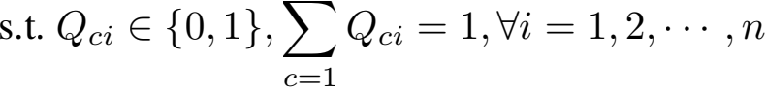

The Thirty-Eighth AAAI Conference on Artiﬁcial Intelligence (AAAI-24)

where X = [x1 , x2,..., xn] ∈ Rd ×n is the input data ma- trix with n instances and d dimensional features, P ∈ Rd ×C is the cluster centroid matrix, and Q ∈ RC ×n is the clus- ter assignment matrix and each column of the matrix Q is a one-hot vector. If xi is assigned to the c-th cluster, then Qci = 1, and Qci = 0, otherwise.

**Multi-view K-means Clustering**

Robust Multi-view K-Means Clustering (RMKMC) gener- alizes K-means to multi-view data (Cai, Nie, and Huang 2013). Suppose that a multi-view data set is composed of

V views for n instances denoted by {x, x , ··· , x}=1 ∈

Rdo . Let Xv ∈ Rdo ×n denote the data of the v-th view, Pv ∈ Rdo ×C be the centroid matrix of the v-th view, Qv ∈ Rn ×C be the clustering indicator matrix of the v- th view. The clustering results of different views should be unique, meaning that the clustering indicator matrices Qv of different views should be consistent. To reduce the nega- tive impact of outlier on K-means clustering, RMKMC uses the sparsity-inducing norm, i.e., ℓ2 , 1 -norm, to replace the F- norm in Eq. (1). The objective function of RMKMC is de- fned as

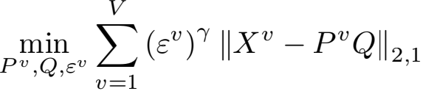

(2)

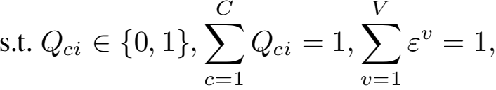

where εv is the weight of the v-th view and γ is the param- eter controlling the weight distribution. Eq. (2) learns the weights of different views, allowing important views to ob- tain big weights.

**The Proposed Approach**

**Formulation**

It is easy to know that, the cluster centroid matrix Pv in Eq. (2) can be calculated by Pv = Xv QT Λ, where Λ ∈ RC×C is a diagonal matrix with the diagonal element

Λcc = 1/  Qci. If we relax the optimization by allowing

Q to be any positive number, and treat all the views equally, the objective of multi-view K-means clustering can be rep- resented as

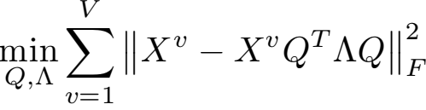

(3)

s.t. Q ≥ 0.

In Eq. (3), we simply use F-norm minimization to make each data point close to the center of the cluster which it belongs to. Here, Qci indicates the probability that the i-th data point belongs to the c-th cluster. Since each column of Q is not one-hot vector, each data point does not defnitely belongs to one cluster. Thus, Eq. (3) can be seen as the objective of Fuzzy Multi-view K-means clustering (FMK), and each column of Xv QT Λ is the fuzzy center.

For a good clustering result, not only each data point is close to the center of the corresponding cluster, but also these centers should be far away from each other, which makes different clusters have stronger separability. To achieve this goal, we maximize the distances between the centers of fuzzy clusters, and obtain the Discriminatively Fuzzy Multi-view K-means clustering (DFMK). Its objec- tive can be formulated as

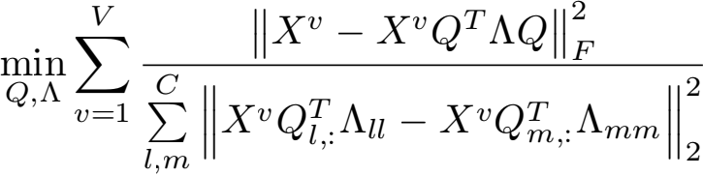

(4)

s.t. Q ≥ 0,

where Ql,: and Qm,: are the l-th and m-th rows of Q, re-

spectively, and Xv Q: Λll and Xv Q: Λmm can be seen as

the centers of the l-th and m-th fuzzy clusters. With Eq. (4), the fuzzy within-cluster scatter is minimized and the fuzzy between-cluster scatter is maximized simultaneously.

DFMK mainly focuses on the global structure of data, but ignores the local structure, which is also important for clustering. From the local perspective, we think that, two data points with strong connection should also have similar cluster assignment result. The connection between two data points can be represented by the adjacent relation of them, and the adjacent matrix Sv ∈ Rn ×n of the v-th view is con- structed as

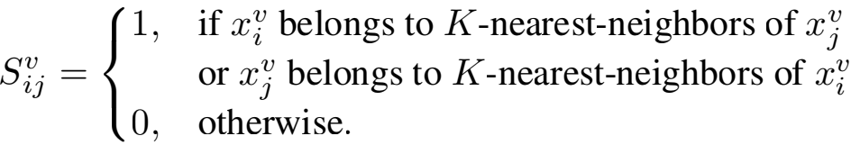

(5) Then, the objective of keeping local clustering structure is

formulated as

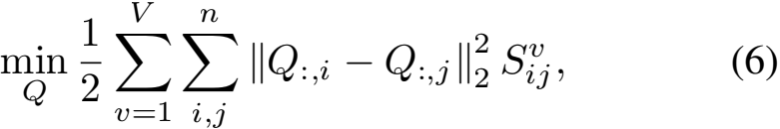

where Q:,i and Q:,j are the i-thandj-th columns of Q, and can be seen as the clustering assignment results of the i-th and j-th data points.

Combining Eq. (4) and Eq. (6), we can obtain the fnalob- jective of Discriminatively Fuzzy Multi-view K-means clus- tering with Local Structure preserving (DFMKLS) as

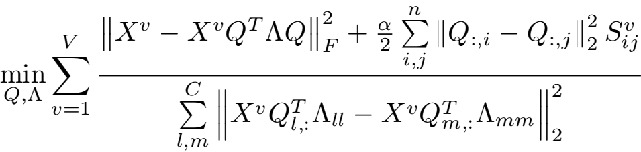

s.t. Q ≥ 0,

(7)

where α ≥ 0 is a trade-off parameter. With Eq. (7), the within-cluster compactness, the between-cluster diversity and the local cluster structure are preserved simultaneously to generate a more reasonable clustering result.

The Thirty-Eighth AAAI Conference on Artiﬁcial Intelligence (AAAI-24)

**Optimization**

The optimization problem in Eq. (7) is non-convex. How- ever, we can solve it by alternating iteration. The following is the iterative update process.

**Step 1:** Update Q with fxed Λ .

For each term in Eq. (7), it can be easily obtained that 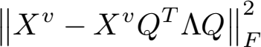

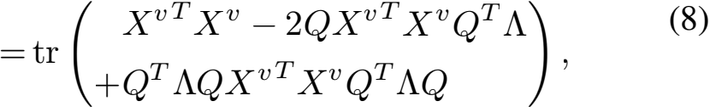

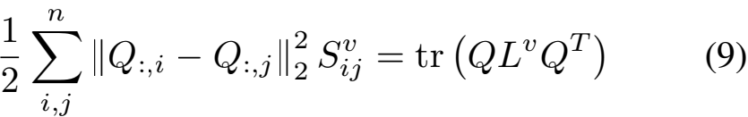

and

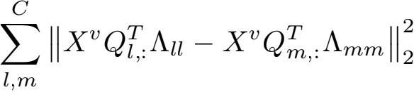

(10)

=2tr (CQT Λ2 QX vTXv − QT Λ1ΛQXvTXv ) ,

where Lv = Dv − Sv is the Laplacian matrix, Dv is a di-

agonal matrix with the diagonal element Di = Σ=1 S ,

and 1 ∈ RC×C is a matrix with all elements equal to 1. Therefore, the optimization problem in Eq. (7) is equivalent to minimizing

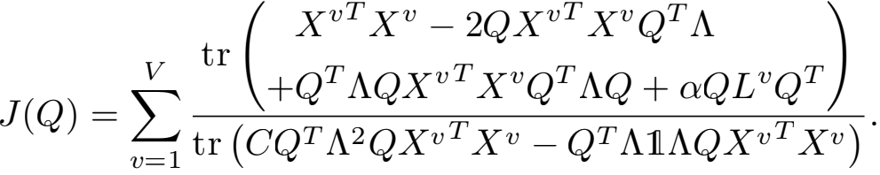

(11)

The partial deviation J(Q) with respect to Q is ∂J(Q)

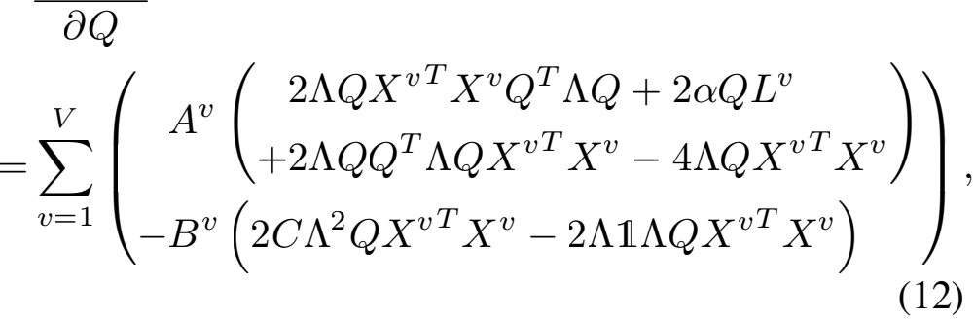

where

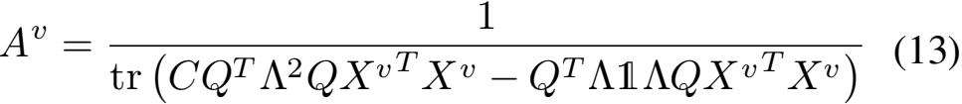

and

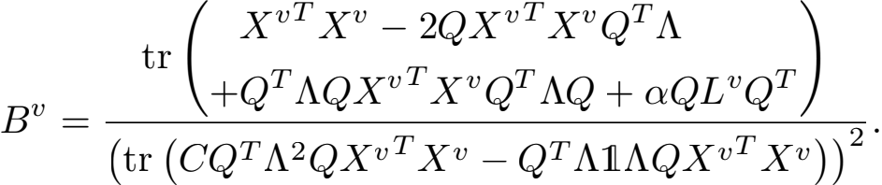

(14)

With the multiplicative update rule (Ding, Li, and Jordan

2010), Q is updated as

Qij

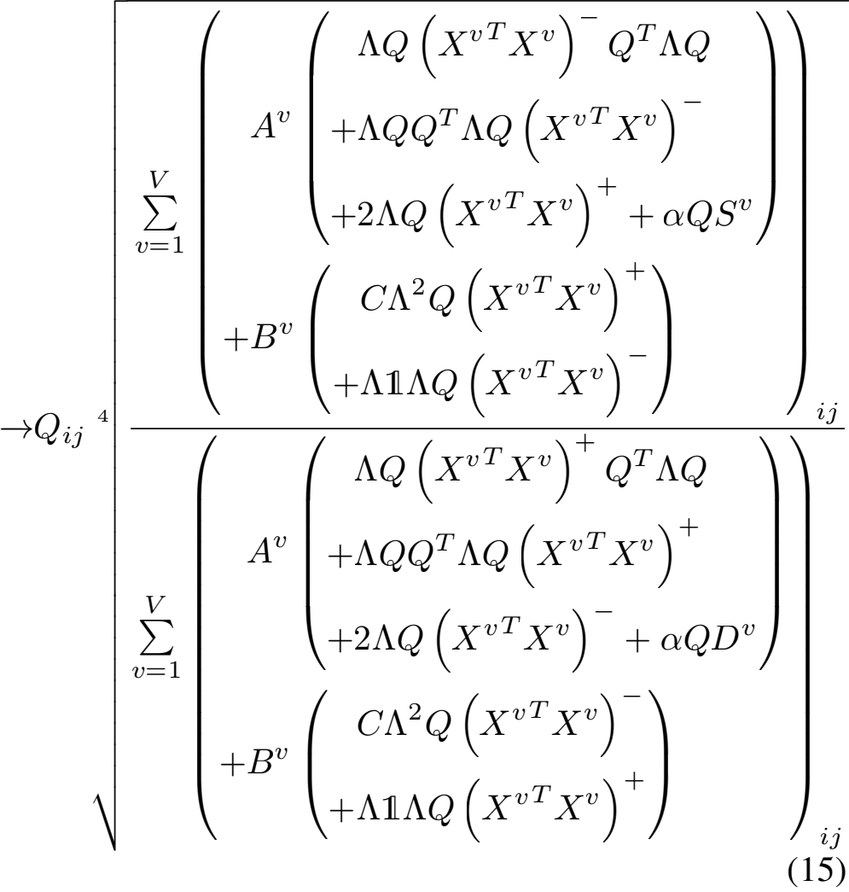

where

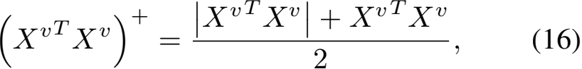

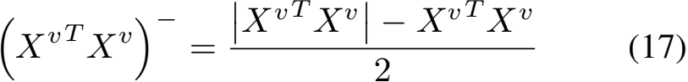

and

XvTXv = (XvTXv )+ − (XvTXv )− . (18)

**Step 2:** Update Λ with fxed Q.

Λ is a diagonal matrix and each diagonal element is updated

as

Λcc = 1/ 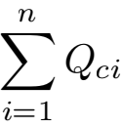 (19)

We summarize the iterative update of DFMKLS in Al- gorithm 1. In the beginning, Q can be simply initialized by random matrix. Here, to obtain relatively stable result, we initialize it by the result of spectral clustering. Specif- cally, the summation of Laplacian matrices from V views,

i.e. Σ=1 Lv , is eigen-decomposed and the eigen-vectors

are used to perform K-means to obtain the cluster assign- ment matrix U ∈ RC×n , where Uci = 1, if xi belongs to the c-th cluster, and Uci = 0, otherwise. Then Q is initialized as Q = U + E/10, where E ∈ RC ×n is a matrix with all elements equal to 1.

**Convergence**

On one hand, the value of objective function of DFMKLS in Eq. (7) is non-negative, which means its lower bound is 0.

Algorithm 1: DFMKLS algorithm

**Input:**

Multi-view data Xv | =1 from V views; Trade-off pa-

rameter α; Neighbor parameter K.

**Output:**

Clustering result. 1: Initialize Q.

2: Construct the adjacent matrix Sv | =1 using Eq. (5),

and compute the diagonal matrix Dv | =1 by Di =

Σ=1 S .

3: **repeat**

4: With fxed Q, update Λ using Eq. (19). 5: With fxed Λ , update Q using Eq. (15). 6: **until** convergence.

7: The label of the ith data point xi is arg axQci.

On the other hand, in the iterative update, with multiplica- tive update rule, the value of the objective function is mono- tonically decreasing. Therefore, DFMKLS algorithm must converge to a local minimum.

**Computational Complexity**

In each iteration, DFMKLS algorithm includes two steps, i.e., Eq. (15) and Eq. (19). It is obviously that the compu- tational complexity of DFMKLS is determined by Eq. (15) and mainly caused by matrix multiplication. There are sev- eral matrix multiplication operations in Eq. (15). Because of C < n, we can easily obtain that, the computational complexities of two most time consuming operations are

O(Cn2 ) and O(Σ=1 dv n2 ), respectively. Therefore, the

computational complexity of DFMKLS is O(T(Cn2 +

Σ=1 dv n2 )), where T is the number of iteration.

**Experiments**

The effectiveness of DFMKLS is evaluated by clustering experiments on four multi-view datasets. Experiments are performed in MATLAB R2014a on a computer with 13th Gen Intel(R) Core(TM) i9-13900K 3.00 GHz CPU, 64.0GB RAM and Windows11 operating system. Accuracy, F-score, Normalized Mutual Information (NMI) and Precision are employed to measure the clustering performance. In the ex- periments, DFMKLS is compared with the following multi- view clustering methods:

**(1) BSV**: Best Single View. K-means is performed in each single view and the best clustering result is adopted.

**(2) Concat**: The features of all the views are concatenated frstand K-means is performed on the combined features.

**(3) MultiNMF** (Liu et al. 2013): Nonnegative Matrix Fac- torization based Multi-view clustering.

**(4) Spec-Pair** (Kumar, Rai, and Daume 2011): Pairwise co- regularization multi-view Spectral clustering. The eigenvec- tors of different views have pairwise similarity in Spec-Pair.

**(5) Spec-Cent** (Kumar, Rai, and Daume 2011): Centroid based co-regularization multi-view Spectral clustering. The eigenvectors of different views tend towards a common con- sensus in Spec-Cent.

**Dataset** Size Class View Dimension

|  |  |  |  |  |
| --- | --- | --- | --- | --- |
| 3Sources | 169 | 6 | 3 | 3068/3631/3560 |
| BBC | 685 | 5 | 4 | 4659/4633/ 4665/4684 |
| WebKB | 1051 | 2 | 2 | 1840/3000 |
| NUS WIDE | 11280 | 10 | 3 | 500/73/128 |

Table 1: Statistic of Datasets

**(6) RMKMC** (Cai, Nie, and Huang 2013): Robust Multi- view K-Means Clustering.

**(7) MVASM** (Han et al. 2020): Multi-View clustering with Adaptive Sparse Memberships and weight allocation.

**(8) EMKMC** (Yang et al. 2023): Effcient Multi-view K- Means Clustering method with multiple anchor graphs.

**(9) GMC** (Wang, Yang, and Liu 2019): Graph-based Multi- view Clustering.

**(10) CGL** (Li et al. 2022): Consensus Graph Learning for multi-view clustering.

**(11) FMK**: Fuzzy Multi-view K-means. Its objective is pre- sented in Eq. (3)

**(12) DFMK**: Discriminatively Fuzzy Multi-view K-means. Its objective is presented in Eq. (4).

**Datasets**

Experiments are conducted on 3sources, BBC, WebKB and NUS WIDE datasets. Table 1 summarizes four datasets, and their details are presented as follows.

**(1) 3Sources** (Greene and Cunningham 2009): It consists of 416 news stories of 6 topical labels, which are collected from 3 sources, i.e., BBC, Reuters, and The Guardian. Each source can be seen as one view of a story. In our experi- ments, we select 169 stories reported in all the 3 sources. The dimensions of three views are 3068, 3631 and 3560, re- spectively.

**(2) BBC** (Greene and Cunningham 2006): It consists of

2225 documents belonging to 5 classes, which are collected from BBC news. Four views are obtained by segmentation of the documents. The dimensions of 4 views are 4659, 4633,

4665 and 4684, respectively. Not all the documents have 4 views. In our experiments, we select 685 documents with 4 complete views.

**(3) WebKB** (Craven et al. 2000): It consists of webpages collected from computer science departments of university, which contains 8,280 documents in 7 categories. In our ex- periments, we select 1,051 documents in the top two most popular categories. Each document has 2 views, and their dimensions are 1840 and 3000,respectively.

**(4) NUS WIDE** (Chua et al. 2009): It consists of 269648 real-world web images. In our experiments, we select 11280 images of mammal, belonging to 10 classes. Each image has

3 views, including 500D bag of words based on SIFT de- scriptions, 73D edge direction histogram and 128D wavelet texture feature.

**Clustering Performance Analysis**

In the comparison experiments, for RMKMC, MVASM, EMKMC, GMC, FMK, DFMK and DFMKLS, the cluster-

The Thirty-Eighth AAAI Conference on Artiﬁcial Intelligence (AAAI-24)

|  |  |  |  |  |
| --- | --- | --- | --- | --- |
| **Method**\**Index** | Accuracy | F-score | NMI | Precision |
| BSV | 0.6183 | 0.6040 | 0.6186 | 0.6608 |
| Concat | 0.6251 | 0.6145 | 0.6448 | 0.6748 |
| MultiNMF | 0.5148 | 0.4236 | 0.4721 | 0.3846 |
| Spec-Pair | 0.5346 | 0.4370 | 0.4332 | 0.4854 |
| Spec-Cent | 0.5308 | 0.4434 | 0.4395 | 0.4972 |
| RMKMC | 0.4320 | 0.3466 | 0.3204 | 0.3414 |
| MVASM | 0.5621 | 0.4555 | 0.3121 | 0.3420 |
| EMKMC | 0.5858 | 0.5324 | 0.4702 | 0.6266 |
| GMC | 0.6923 | 0.6047 | 0.6216 | 0.4844 |
| CGL | 0.6393 | 0.6166 | 0.6995 | 0.7127 |
| FMK | 0.7396 | 0.6866 | 0.6818 | 0.6912 |
| DFMK | 0.7396 | 0.7091 | 0.7066 | 0.6800 |
| DFMKLS | **0.8107** | **0.7483** | **0.7096** | **0.7598** |

Table 2: Cluster Validity Index on 3Sources dataset

|  |  |  |  |  |
| --- | --- | --- | --- | --- |
| **Method**\**Index** | Accuracy | F-score | NMI | Precision |
| BSV | 0.5856 | 0.4948 | 0.4676 | 0.4659 |
| Concat | 0.6674 | 0.6057 | 0.6082 | 0.5973 |
| MultiNMF | 0.4804 | 0.3817 | 0.3335 | 0.2869 |
| Spec-Pair | 0.3056 | 0.3276 | 0.0379 | 0.2312 |
| Spec-Cent | 0.3092 | 0.3314 | 0.0381 | 0.2316 |
| RMKMC | 0.6015 | 0.4833 | 0.4357 | 0.4839 |
| MVASM | 0.3314 | 0.3757 | 0.0197 | 0.2339 |
| EMKMC | 0.6584 | 0.5673 | 0.5020 | 0.6111 |
| GMC | 0.6934 | 0.6333 | 0.5628 | 0.5012 |
| CGL | 0.8068 | 0.7390 | 0.6972 | 0.7373 |
| FMK | 0.5547 | 0.5477 | 0.5148 | 0.4864 |
| DFMK | 0.6496 | 0.6627 | 0.5784 | 0.5708 |
| DFMKLS | **0.8672** | **0.8159** | **0.7341** | **0.8054** |

Table 3: Cluster Validity Index on BBC dataset

ing results can be obtained directly. For MultiNMF, Spec- Pair, Spec-Cent and CGL, new features are frstly extracted and then K-means is performed on these features. We per- form K-means 20 times and report the average value of Ac- curacy, F-score, NMI and Precision. The parameters of the compared methods are set as the recommendations of the original papers. For DFMKLS, the trade-off parameter α is set as 0.01, and the neighbor parameter K is set as 10. Pa- rameter setting will be analyzed in the following section. From Table 2, Table 3 and Table 4, it can be seen that, on 3Sources, BBC and WebKB datasets, DFMKLS all obtains the best clustering performance, no matter which cluster va- lidity index is adopted. From Table 5, it can be found that, on NUS WIDE dataset, our DFMKLS has the highest ac- curacy, F score and precision. Besides, on all the datasets, DFMK almost performs better than FMK by introducing the discriminant information. By combining the global informa- tion and the local information, DFMKLS improves the clus- tering performance of DFMK further.

**Parameter Analysis**

To fnd the optimal parameters forDFMKLS, we let the pa- rameters α and K vary in a wide range, and evaluate the performances of DFMKLS with different parameters. Ex-

|  |  |  |  |  |
| --- | --- | --- | --- | --- |
| **Method**\**Index** | Accuracy | F-score | NMI | Precision |
| BSV | 0.8754 | 0.8539 | 0.3882 | 0.7666 |
| Concat | 0.8844 | 0.8777 | 0.5546 | 0.8432 |
| MultiNMF | 0.8647 | 0.8454 | 0.3465 | 0.7515 |
| Spec-Pair | 0.9134 | 0.8891 | 0.5322 | 0.8242 |
| Spec-Cent | 0.9134 | 0.8891 | 0.5322 | 0.8242 |
| RMKMC | 0.9515 | 0.9319 | 0.6618 | 0.9039 |
| MVASM | 0.9439 | 0.9160 | 0.6785 | 0.9564 |
| EMKMC | 0.9305 | 0.9061 | 0.5588 | 0.8671 |
| GMC | 0.7764 | 0.7867 | 0.0017 | 0.6596 |
| CGL | 0.5271 | 0.5688 | 0.0040 | 0.6589 |
| FMK | 0.8687 | 0.8434 | 0.3122 | 0.7682 |
| DFMK | 0.9467 | 0.9210 | 0.6591 | 0.9492 |
| DFMKLS | **0.9610** | **0.9416** | **0.7276** | **0.9638** |

Table 4: Cluster Validity Index on WebKB dataset

|  |  |  |  |  |
| --- | --- | --- | --- | --- |
| **Method**\**Index** | Accuracy | F-score | NMI | Precision |
| BSV | 0.2194 | 0.1693 | 0.0791 | 0.1716 |
| Concat | 0.2217 | 0.1571 | 0.0812 | 0.1696 |
| MultiNMF | N/A | N/A | N/A | N/A |
| Spec-Pair | 0.2172 | **0.2491** | 0.0102 | 0.1423 |
| Spec-Cent | 0.2171 | 0.2490 | 0.0099 | 0.1423 |
| RMKMC | 0.2191 | 0.1548 | 0.0720 | 0.1740 |
| MVASM | 0.2098 | 0.1521 | 0.0699 | 0.1704 |
| EMKMC | 0.1664 | 0.1342 | 0.0404 | 0.1552 |
| GMC | 0.2214 | 0.2444 | 0.0402 | 0.1452 |
| CGL | 0.2290 | 0.1590 | 0.0890 | 0.1789 |
| FMK | 0.2252 | 0.1899 | 0.0764 | 0.1675 |
| DFMK | 0.2331 | 0.1807 | 0.0905 | 0.1770 |
| DFMKLS | **0.2453** | 0.1886 | **0.0966** | **0.1817** |

Table 5: Cluster Validity Index on NUS WIDE dataset

periments are performed on 3Sources, BBC, WebKB and NUS WIDE datasets. For two parameters, we fx one param- eter and change the other one. Specifcally, K isfxed as 10 and α is selected from the set {10−4 , 10 −3 , . . . , 103 , 104 }. Then, α is fxed as 0.01, and K is selected from the set {2, 4, . . . , 18, 20}. Fig.1 and Fig.2 show the values of four cluster validity indexes under different α and K, respec- tively. From Fig.1, we can see that, too big α leads to the dramatic decrease of clustering validity indexex, especially for NMI. It indicates that, in DFMKLS model, the local structure preserving term cannot occupy too high propor- tion, the model should focus more on the objective of dis- criminatively fuzzy multi-view K-means. On all the datasets, DFMKLS almost performs best with α = 0.01. From Fig.2, we can see that, on 3sources and BBC datasets, DFMKLS has poor performances with too big or too small K and per- forms well with K ∈ [8, 18]. K has small effect on the clustering results on WebKB and NUS WIDE datasets. On all the datasets, DFMKLS obtains relatively good clustering performance with K = 10. According to the result of pa-

The Thirty-Eighth AAAI Conference on Artiﬁcial Intelligence (AAAI-24)

objective value become smooth and steady, and then the al-

rameter analysis, in our experiments, the parameter α is set as 0.01, and K is set as 10.

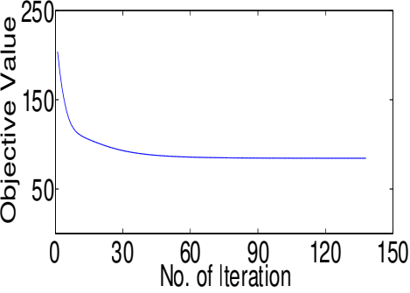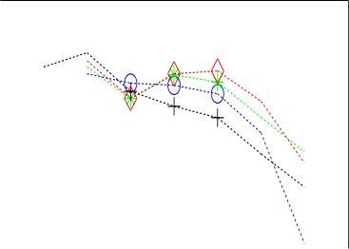gorithm converges. Besides, for larger datasets,i.e., WebKB and NUS WIDE, DFMKLS needs more iterations to reach convergence.

Object ive Value

|  |  |
| --- | --- |
| 1 |  |

|  |
| --- |
|  |

0.5

NMI

5000

3000

1000

0.5

F_score Precision

|  |
| --- |
|  |

Accuracy 

0

|  |
| --- |
| 1 |
| NMI  F_score  Precision  0 Accuracy |

0.0001 0.01 1 100 10000

0.0001 0.01 1 100 10000

α

α

(a) 3Sources

(b) BBC

0 30 60 90 120

No. of Iteration (b) BBC

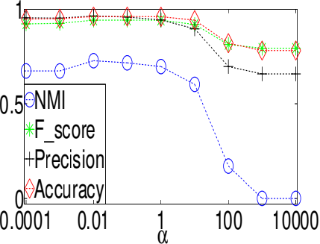

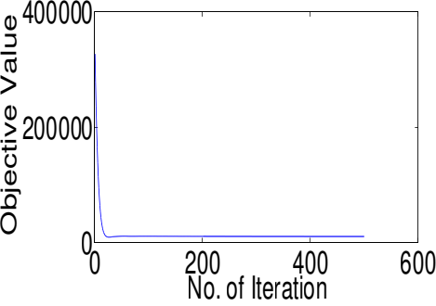6000

Object ive Value

(a) 3Sources

0.6 0.4 0.2 0

|  |  |
| --- | --- |
|  | NMI  F_score Precision Accuracy |
|  | |
|  | |
|  | |

|  |
| --- |
|  |

4000

2000

0.0001 0.01 1 100 10000

α

0

(d) NUS WIDE

(c) WebKB

0 100 200 300 400 500

No. of Iteration

Figure 1: Cluster Validity Index of DFMKLS versus param- eter α

(c) WebKB

(d) NUS WIDE

Figure 3: The value of objective function of DFMKLS ver- sus iteration

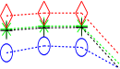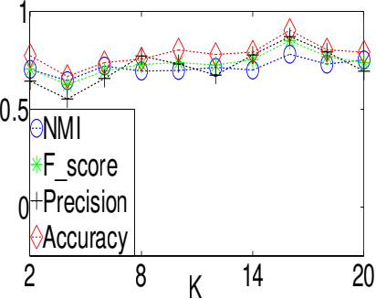

**Conclusion**

|  |  |
| --- | --- |
| 1    0 | NMI  F_score Precision Accuracy |

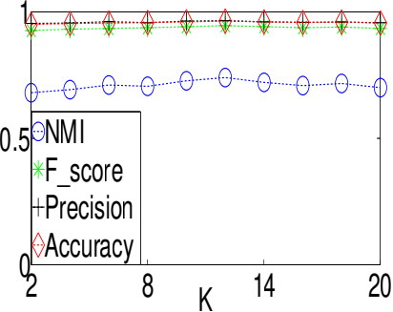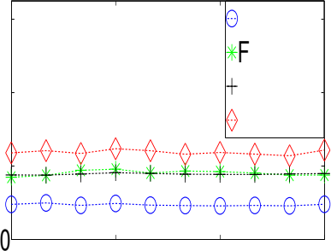This paper develops a novel multi-view K-means clustering method called DFMKLS. DFMKLS takes into account the compactness of each cluster and the separability of differ- ent clusters simultaneously, where the within-cluster scatter is minimized and the between-cluster scatter is maximized. In DFMKLS, a data point does not strictly belong to one cluster. The probability that it belongs to each cluster is cal- culated and it is assigned to the cluster with the maximum probability. DFMKLS also preserves the local structure of the data to improve the clustering performance. We conduct experiments on four public multi-view datasets and compare DFMKLS with state-of-the-art multi-view clustering meth- ods. Experimental results demonstrate the effectiveness of DFMKLS. In addition, the optimal parameters forDFMKLS are established by parameter analysis experiments, and the convergence of the algorithm is also proved in experiments.

0.5

14 20

2 8

K

(b) BBC

(a) 3Sources

0.6 NMI

_score

0.4 Precision Accuracy

0.2

2 8 K 14 20

(d) NUS WIDE

(c) WebKB

**Acknowledgments**

Figure 2: Cluster Validity Index of DFMKLS versus param- eter K

This work is supported by National Natural Science Foundation of China (62076096), Shanghai Pujiang Program (22PJD029) and Shanghai Municipal Project (20511100900).

**Convergence Analysis**

We evaluate the convergence of DFMKLS algorithm on four multi-view datasets. The value of objective function of DFMKLS is recorded in each iteration and displayed in Fig.3. From the fgure, we can fnd that, on all the datasets, the objective value declines rapidly in the beginning of the iteration. After no more than 100 iterations, the curves of the

**References**

Asano, Y.; Patrick,M.; Rupprecht, C.; and Vedaldi,A. 2020. Labelling unlabelled videos from scratch with multi-modal self-supervision. *Proceedings of Advances in Neural Infor- mation Processing Systems*, 33: 4660–4671.

16484

The Thirty-Eighth AAAI Conference on Artiﬁcial Intelligence (AAAI-24)

Cai, X.; Nie, F.; and Huang, H. 2013. Multi-view k-means clustering on big data. In *Proceedings of the International Joint Conference on Artifcial Intelligence*, 2598–2604.

Cao, X.; Zhang, C.; Fu, H.; Liu, S.; and Zhang, H. 2015. Diversity-induced multi-view subspace clustering. In *Pro- ceedings of the IEEE Conference on Computer Vision and Pattern Recognition*, 586–594.

Chen, C.; Wang, Y.; Hu, W.; and Zheng, Z. 2020. Ro- bust multi-view k-means clustering with outlier removal. *Knowledge-Based Systems*, 210: 106518.

Cheng,M.; Jing,L.; and Ng,M. K. 2018. Tensor-based low- dimensional representation learning for multi-view cluster- ing. *IEEE Transactions on Image Processing*, 28(5): 2399– 2414.

Cheung, Y.-M. 2003. K-means: a new generalized k-means clustering algorithm. *Pattern Recognition Letters*, 24(15): 2883–2893.

Chua, T.-S.; Tang, J.; Hong, R.; Li, H.; Luo, Z.; and Zheng, Y.-T. 2009. NUS-WIDE: a real-world web image database from national university of singapore. In *Proceedings of ACM Conference on Image and Video Retrieval*, 1–9.

Craven, M.; DiPasquo, D.; Freitag, D.; McCallum, A.; Mitchell, T.; Nigam, K.; and Slattery, S. 2000. Learning to construct knowledge bases from the World Wide Web. *Arti- fcial Intelligence*, 118(1): 69–113.

Ding, C. H.; Li, T.; and Jordan, M. I. 2010. Convex and semi-nonnegative matrix factorizations. *IEEE Transactions on Pattern Analysis and Machine Intelligence*, 32(1): 45–55. Greene, D.; and Cunningham, P. 2006. Practical Solutions to the Problem of Diagonal Dominance in Kernel Document Clustering. In *Proceedings of International Conference on Machine learning*, 377–384.

Greene, D.; and Cunningham, P. 2009. A Matrix Factoriza- tion Approach for Integrating Multiple Data Views. In *Pro- ceedings of Joint European Conference on Machine Learn- ing and Knowledge Discovery in Databases*, 423–438.

Han,J.; Xu,J.; Nie,F.; and Li,X. 2020. Multi-view k-means clustering with adaptive sparse memberships and weight al- location. *IEEE Transactions on Knowledge and Data Engi- neering*, 34(2): 816–827.

Kumar, A.; Rai, P.; and Daume, H. 2011. Co-regularized multi-view spectral clustering. *Proceedings of Advances in Neural Information Processing Systems*, 24.

Li, R.; Zhang, C.; Fu, H.; Peng, X.; Zhou, T.; and Hu, Q. 2019. Reciprocal multi-layer subspace learning for multi- view clustering. In *Proceedings of the IEEE International Conference on Computer Vision*, 8172–8180.

Li, Z.; Tang, C.; Liu, X.; Zheng, X.; Zhang, W.; and Zhu, E. 2022. Consensus graph learning for multi-view clustering. *IEEE Transactions on Multimedia*, 24: 2461–2472.

Liang, W.; Liu, X.; Zhou, S.; Liu, J.; Wang, S.; and Zhu, E. 2022. Robust graph-based multi-view clustering. In *Pro- ceedings of the AAAI Conference on Artifcial Intelligence*, 7462–7469.

Liu, J.; Cao, F.; Gao, X.-Z.; Yu, L.; and Liang, J. 2020a. A cluster-weighted kernel k-means method for multi-view

clustering. In *Proceedings of the AAAI Conference on Arti- fcial Intelligence*, volume 34, 4860–4867.

Liu, J.; Wang, C.; Gao, J.; and Han, J. 2013. Multi-view clustering via joint nonnegative matrix factorization. In

*Proceedings of the SIAM International Conference on Data Mining*, 252–260.

Liu, X.; Li, M.; Tang, C.; Xia, J.; Xiong, J.; Liu, L.; Kloft, M.; and Zhu, E. 2020b. Effcient and effective regular- ized incomplete multi-view clustering. *IEEE Transactions on Pattern Analysis and Machine Intelligence*, 43(8): 2634– 2646.

MacQueen, J. 1967. Some methods for classifcation and analysis of multivariate observations. In *Proceedings of Symposium on Mathematical Statistics and Probability*, 281–297.

Nie, F.; Li, J.; Li, X.; et al. 2017. Self-weighted multiview clustering with multiple graphs. In *Proceedings of the Inter- national Joint Conference on Artifcial Intelligence*, 2564– 2570.

Peng, L.; Yang, Y.; Wang, Z.; Huang, Z.; and Shen, H. T. 2020. Mra-net: Improving vqa via multi-modal relation at- tention network. *IEEE Transactions on Pattern Analysis and Machine Intelligence*, 44(1): 318–329.

Sun, S. 2013. A survey of multi-view machine learning. *Neural Computing and Applications*, 23: 2031–2038.

Wang, H.; Yang, Y.; and Liu, B. 2019. GMC: Graph-based multi-view clustering. *IEEE Transactions on Knowledge and Data Engineering*, 32(6): 1116–1129.

Wang, Z.; Li, Z.; Wang, R.; Nie, F.; and Li, X. 2020. Large graph clustering with simultaneous spectral embedding and discretization. *IEEE Transactions on Pattern Analysis and Machine Intelligence*, 43(12): 4426–4440.

Xu, J.; Han, J.; and Nie, F. 2016. Discriminatively embed- dedk-means for multi-view clustering. In *Proceedings of the IEEE Conference on Computer Vision and Pattern Recogni- tion*, 5356–5364.

Xu, J.; Han, J.; Nie, F.; and Li, X. 2017. Re-weighted dis- criminatively embedded k-means for multi-view clustering. *IEEE Transactions on Image Processing*, 26(6): 3016–3027. Xu, J.; Tang, H.; Ren, Y.; Peng, L.; Zhu, X.; and He, L. 2022. Multi-Level feature learning for contrastive multi- View clustering. In *Proceedings of the IEEE Conference on Computer Vision and Pattern Recognition*, 16051–16060.

Xu, R.; and Wunsch, D. 2005. Survey of clustering algo- rithms. *IEEE Transactions on Neural Networks*, 16(3): 645– 678.

Yang, B.; Zhang, X.; Li, Z.; Nie, F.; and Wang, F. 2023. Ef- fcient multi-view k-means clustering with multiple anchor graphs. *IEEE Transactions on Knowledge and Data Engi- neering*, 35(7): 6887–6900.

Ye, Y.; Liu, X.; Yin, J.; and Zhu, E. 2016. Co-regularized kernel k-means for multi-view clustering. In *Proceedings of International Conference on Pattern Recognition*, 1583– 1588.

Zhang, Z.; Liu, L.; Shen, F.; Shen, H. T.; and Shao, L. 2018. Binary multi-view clustering. *IEEE Transactions on Pattern Analysis and Machine Intelligence*, 41(7): 1774–1782.